Concurrent Orchestration

Overview
The concurrent orchestration pattern enables multiple agents to work on the same task in parallel. Each agent processes the input independently, and their results are aggregated. This is useful for brainstorming, ensemble reasoning, or voting systems.

Concurrent orchestration workflow
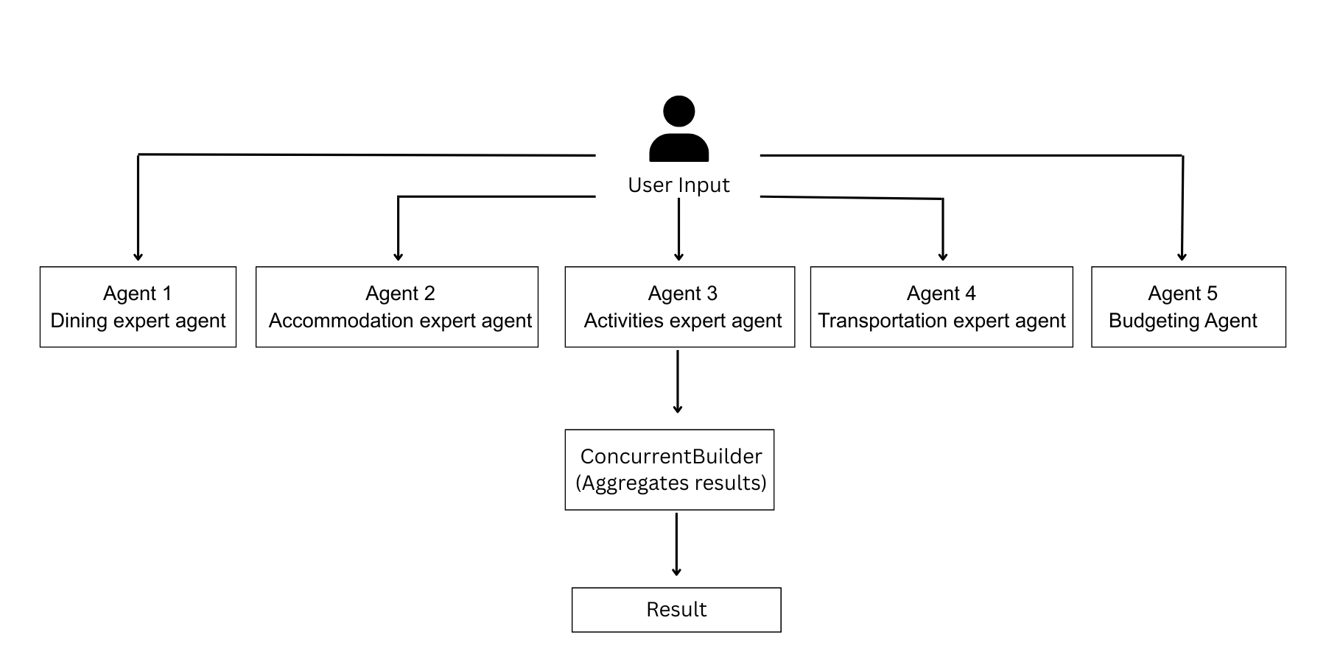
Key Features
- Agents
- Concurrent builder
Prerequisites
Before starting, make sure you have:
- Azure openAI Credentials in env.
  - AZURE_OPENAI_API_KEY="YOUR_API_KEY"
  - AZURE_OPENAI_ENDPOINT="YOUR ENDPOINT"
  - AZURE_OPENAI_CHAT_DEPLOYMENT_NAME="gpt-4o"
  - AZURE_OPENAI_API_VERSION="2024-12-01-preview"
- Agent-framework installed.
  - pip install agent-framework

